**Project Title: Deploy Angular Application in Docker Container**

**Note: This is a solution document on how the demonstration is performed on Docker 18.+ version.**

Install Angular application on Ubuntu by running the commands mentioned below:

sudo apt-get update

curl -sL https://deb.nodesource.com/setup_10.x | sudo -E bash -

apt-get install -y nodejs

npm install -g @angular/cli

ng new myAng-app

cd myAng-app

Run the application in the browser.

ng serve --open

A default browser should open automatically displaying you the Angular application. If you do not see the output, open any browser and add the url in the search bar of the browser:

<https://localhost:4200>

Your browser should load the output mentioned in the screenshot:

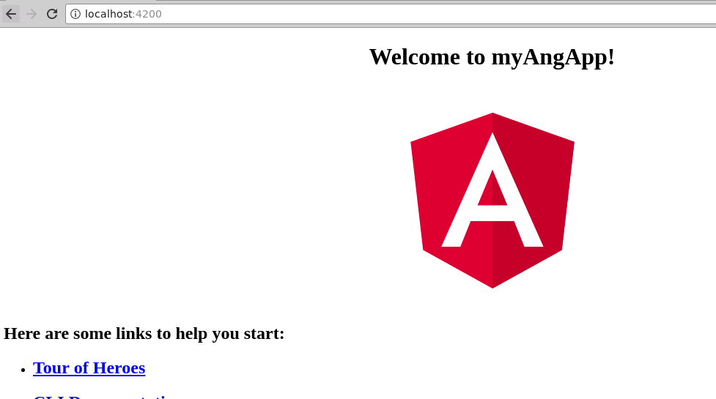

Navigate inside the project, and create a Dockerfile.

touch Dockerfile

Now add the following content to it.

# base image

FROM node:9.6.1

# install chrome for protractor tests

# set working directory

RUN mkdir /usr/src/app

WORKDIR /usr/src/app

# add `/usr/src/app/node_modules/.bin` to $PATH

ENV PATH /usr/src/app/node_modules/.bin:$PATH

# install and cache app dependencies

COPY package.json /usr/src/app/package.json

RUN npm install

RUN npm install -g @angular/cli@1.7.1

# add app

COPY . /usr/src/app

# start app

CMD ng serve --host 0.0.0.0

Create another “dockerignore” file.

touch .dockerignore

Write the following content in it:

node_modules

.git

Build and tag the docker image.

docker build -t myangularapp .

Then reload the container by executing the command mentioned below:

docker run -it -p 4200:4200 myangularapp

Open the browser, and you should be able to run the application in the browser by navigating to the URL mentioned below.

<https://localhost:4200>

Exit the execution of application, and now run the Angular application in docker detach mode.

docker run -d -p 4200:4200 myangularapp

Now, open the browser, and you should be able to run the application in the browser by navigating to the URL mentioned below.

<https://localhost:4200>

You will be able to load the Angular application page in your browser.

Now, check if the container is running.

docker images

Now tag the running container.

docker tag <ContainerID> <DockerHubUsername>/<ImageName>:<tagName>

Login to Docker Hub.

docker login - - username=yourdockerhubusername –email=registeredemail.

Enter the password when prompted.

Push the image to Docker Hub.

docker push <DockerHubUsername>/<ImageName>:<tagName>

Go to your Docker Hub account, and reload the page. You should be able to find the image available in the Docker Hub.